1. A strong capillary tube filled with mercury and closed at 0C is heated to 10C. Assuming the volume of the capillary remains constant, calculate the resulting pressure. For mercury near room temperature the expansion coefficient α is 18x10-5 per degree C and the compressibility β is 3.7x10-6 per atmosphere.

**3 marks**

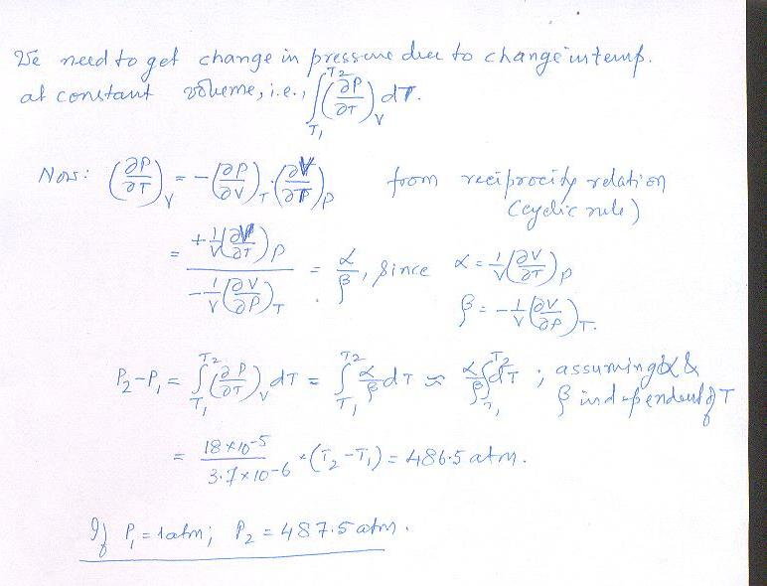

1. (a) 1kg of liquid water is enclosed under a frictionless weightless piston at 90C and 0.68 atm. pressure.(This is the vapour pressure of water at 90C). The pressure above the piston is lowered infinitesimally below this value and the water allowed to vaporize isothermally until all vaporized. For this process, q=40,710 joules. The specific volume of water at 100C is 1.043x10-3 m3/kg, and the specific volume of steam is 1.713 m3/kg at 90C and 1 atm. Calculate the work ω attending this vaporization and ΔE and $∆H$ for the process. **2 marks**

(b)Find the values of $∆E$, ΔH, w and q for the process where, with the same initial state as above, pressure above the piston is set to zero and the water is allowed to vaporize freely and isothermally into an evacuated

space of such volume that the pressure finally builds upto 0.68atm. and temp remains at 90C, when all the water is vaporized. **2 marks**

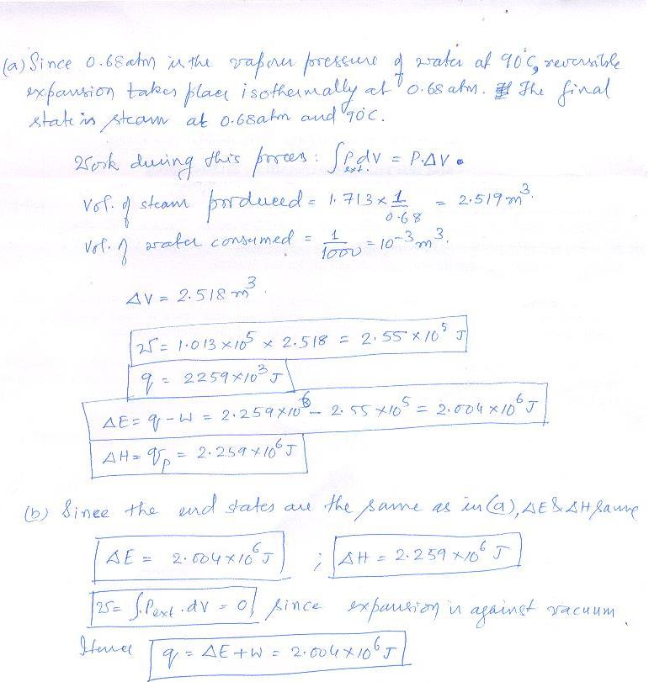

1. One mole of an ideal diatomic gas at 25C and 1 atm pressure is allowed to expand adiabatically against vacuum to twice its volume. Suggest two ways in which the system can be restored to its original state (you need to allow heat transfer ?). What is the effect on the surrounding in the two cases? **3 marks**

